**How to Install SQL Developer?**

1. **Download**: go to <https://www.oracle.com/tools/downloads/sqldev-downloads.html>, and download SQL Developer with JDK 11 included for your machine. You need an account with Oracle to download its software. Create one if you do not have one.
2. **Install**: If you are a Windows user, extract the downloaded zip file and create a shortcut on the desktop to sqldeveloper.exe. If you are Mac user, extract the downloaded zip, move the corresponding .app file to your Applications folder, and keep the application on the dock.
3. **Connect**: Start SQL developer and create/save an Oracle connection as illustrated below. The name could be anything (*cs301* in the illustration), but the hostname for the Oracle server shall be *oracle.cs.ua.edu* (managed by College of Engineering). Your username is *your crimson id*, and your password is *your CWID*. A VPN connection is required if you try to connect to the Oracle sever from off-campus.

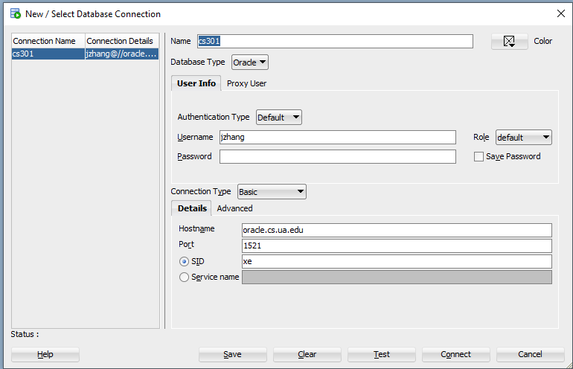

1. **Test**: Enter the query select * from dual; in *Worksheet* and click the run icon (a green arrow). Make sure you see a one element table in *Query Result*.
2. **Change Password**: When connected, right-click the Oracle connection to bring up the menu, select *Reset Password* to bring up the *Enter New Password* dialog box, and change the password from your CWID to a more secure one.